Lead Agent — Setup, Dry Run and Daily Use Guide
Cold-email lead pipeline: IG Email Extractor → Instantly → Master Sheet
Version 1.0 · 30 October 2026

1. What this is
The Lead Agent automates the lead-preparation work the team does by hand today. After you export a list from IG Email Extractor, the agent cleans it, removes leads you have already contacted, keeps only good-fit prospects, checks every email on Bouncify, writes a personalised first line for each lead, adds them to your new Instantly campaign and records them in the Cold Email tab of the master sheet.
What stays with the team: exporting from IG Email Extractor, duplicating the campaign in Instantly, reviewing the report, and starting the campaign. The agent never starts a campaign or sends an email itself.
 | Before (manual) | With the Lead Agent
Sorting the export | By eye, per person | Same rules every time (filters + team keyword list + AI fit check)
Duplicate check | Manual in the master sheet | Automatic against all ~71,000 emails and usernames in the Cold Email tab
Email verification | Upload to Bouncify, download, re-merge | Automatic via Bouncify API, same credits
Personalisation | None or manual | One first line per lead from their bio, written and checked by a local AI
Instantly upload | CSV upload | Automatic into the newest Draft (New-mails) campaign
Master sheet update | Copy-paste | Automatic

2. How it works (architecture)
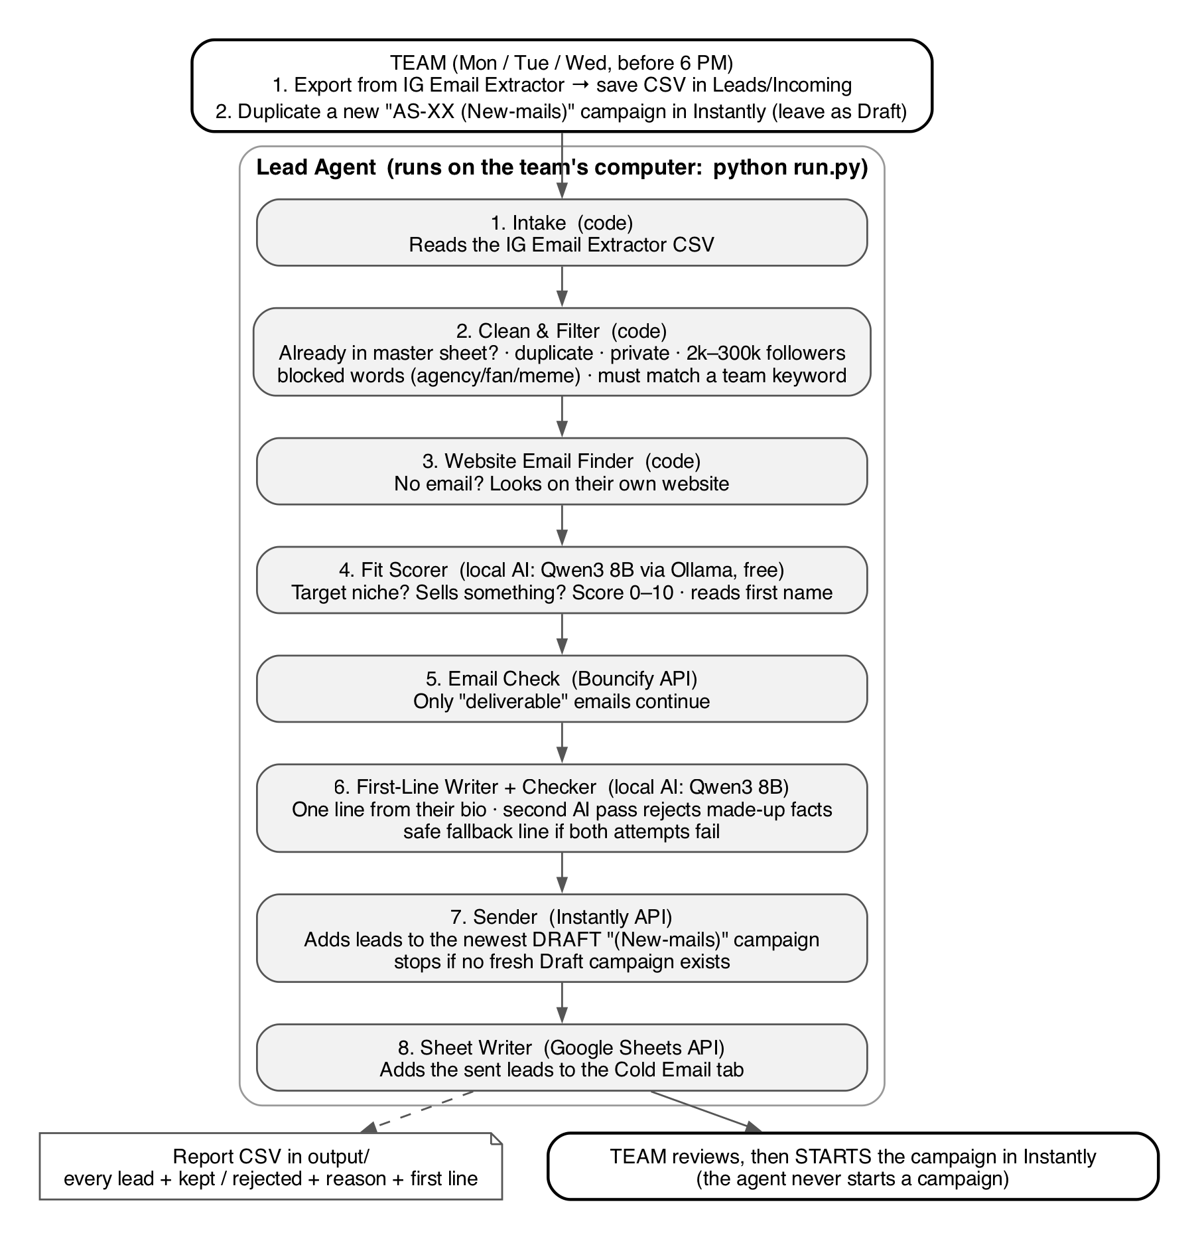
Step | What it does | Runs on
1. Intake | Reads every CSV in Leads/Incoming and checks it has the 17 IG Email Extractor columns. | Code
2. Clean & Filter | Removes: leads already in the Cold Email tab (email or username), duplicates inside the file, private accounts, followers outside 2,000–300,000, bios with blocked words (marketing agency, SMMA, fan page, meme…), and bios that match none of the team's keywords. | Code
3. Website Email Finder | If a lead has no email, looks on their own website (home, contact, about pages). | Code
4. Fit Scorer | Local AI scores 0–10: in a target niche and selling something? Below 6 is removed. Also reads the real first name. | Ollama (free, on the computer)
5. Email Check | Checks each email on Bouncify. Only 'deliverable' continues. Uses the account's normal Bouncify credits. | Bouncify API
6. First Line | Local AI writes one opening sentence from the bio; a second AI pass rejects lines with made-up facts. If both attempts fail, a safe standard line is used. | Ollama
7. Sender | Adds the leads to the newest 'AS-XX (New-mails)' campaign — only if it is still a Draft and was created in the last 24 hours. Otherwise it stops. | Instantly API
8. Sheet Writer | Adds the leads that reached Instantly to the Cold Email tab (A: Agent (date), B: Name, C: Niche, D: Email, E: Followers, F: Profile URL). | Google Sheets API

3. What has been built and tested
- All eight steps are built and working end to end in test mode.
- Instantly API key tested: it reads all campaigns (117 found) and has permission to add leads.
- Bouncify API key tested: it reads the credit balance (12,986 credits at the time of testing).
- Master sheet duplicate check tested against the live Cold Email tab: 273 of the 348 leads in the sample export were already in the sheet and were correctly removed.
- The team's keyword list (274 words) is built in, plus 47 extra words in a separate group 'added_by_agent' (singular forms such as program/course/session, and niche words such as acupuncture, fertility, menopause, career, speaker, author).
Full test on the 348-lead sample (duplicate check switched off so all steps could be tested):
Stage | Leads left | Removed because
Loaded | 348
Clean, dedupe and keywords | 142 | 60 over 300k followers · 55 under 2k · 53 duplicates in the file · 30 no keyword · 8 private
AI fit check | 129 | 10 low fit · 3 off-niche
Ready for Instantly | 129 | Run time on a 16 GB laptop: about 25 minutes for 348 leads

Known limits:
- The local AI is free and private but small: roughly 1 in 10 first lines is a little awkward, and about 15% of leads get the standard fallback line. Skim the report before every live run.
- Leads with no real first name (clinic or brand pages) get 'there' as the first name, so the email reads 'Hi there'.
- Because the keyword list includes 'shop now', 'our products' etc., small product brands in the target niches also pass.

4. One-time setup (team)
Do these once, on the computer that will run the agent. Recommended: a Mac or Windows laptop/desktop with 16 GB RAM.

4.1 Computer
- Copy the whole 'lead-gen-agent' folder onto the computer (for example to the Desktop).
- Install Python 3.10 or newer from python.org (Windows: tick 'Add Python to PATH' during install).
- Install Ollama from ollama.com and open it once (it then runs in the background).
- Open Terminal (Mac) or Command Prompt (Windows) and download the AI model (about 5 GB, one time):
ollama pull qwen3:8b
- In the same window, go into the folder and install the agent's libraries:
cd "path/to/lead-gen-agent"
python3 -m venv .venv (Windows: python -m venv .venv)
.venv/bin/pip install -r requirements.txt (Mac)
.venv\Scripts\pip install -r requirements.txt (Windows)

4.2 Instantly API key
- Instantly → Settings → Integrations → API Keys → make sure 'Version 2' is selected → Create API Key.
- Name it 'Lead Agent'. Tick only two permissions: leads:create and campaigns:read.
- Copy the key immediately — Instantly shows it only once.
- In the campaign you duplicate each time, open the Editor → email step 1 → place the cursor at the top → Variables → Personalization. Use Preview → 'Load data for lead' to check. Keep the unsubscribe line and postal address in the footer.
Source: developer.instantly.ai (Quickstart) and help.instantly.ai (Variables in campaigns).

4.3 Bouncify API key
- Log in at app.bouncify.io and open the API page; the API key is shown there.
- Copy the key. Make sure the account has credits — every email the agent checks uses Bouncify credits.
Source: bouncify.io/docs (API Authentication, Single Validation).

4.4 Put the keys in the .env file
Inside the folder there is a hidden file called .env (Mac: press Cmd + Shift + . in Finder to show hidden files). Open it with TextEdit / Notepad and paste the keys after the = signs, with no spaces:
INSTANTLY_API_KEY=paste-here
BOUNCIFY_API_KEY=paste-here
Never share this file or paste keys into chat, email or WhatsApp.

4.5 Google access to the master sheet (service account)
A service account is a 'robot' Google account. It can only open sheets you share with it. Steps from the official gspread documentation (docs.gspread.org):
- Go to console.cloud.google.com, sign in with the team's Google account, and create a new project (e.g. 'Lead Agent').
- In the top search bar find 'Google Sheets API' → Enable. Then find 'Google Drive API' → Enable.
- Go to APIs & Services → Credentials → Create credentials → Service account. Enter a name → Create → Done.
- Click the ⋮ menu next to the new service account → Manage keys → Add key → Create new key → JSON → Create. A .json file downloads.
- Rename the file to google_service_account.json and move it into the folder lead-gen-agent/secrets/.
- Open the .json file, copy the address next to "client_email" (ends in iam.gserviceaccount.com). Open the master lead sheet → Share → paste that address → give it Editor access → Send.
Treat the .json file like a password. Only the sheet owner or an editor can do the sharing step.

4.6 Check the setup
Run a test (section 5). The first lines of the output confirm each connection:
Instantly campaign: AS-XX (New-mails)
Bouncify credits: 12,986
Master sheet: 71,327 emails ... already used

5. Dry run (test) — do this before the first live run
A dry run does everything except sending: nothing goes to Instantly and nothing is written to the sheet.
- Create a test campaign in Instantly: duplicate any New-mails campaign and name it 'AS-TEST (New-mails)'. Leave it as a Draft.
- Put a fresh IG Email Extractor export (one not yet added to the master sheet) into the folder Leads/Incoming.
- Make sure the Ollama app is open.
- In Terminal / Command Prompt, inside the lead-gen-agent folder, run:
.venv/bin/python run.py --verify (Mac)
.venv\Scripts\python run.py --verify (Windows)
'--verify' also checks emails on Bouncify, so it uses credits. Leave it out for a completely free test (emails are then marked 'not checked').
- Wait for it to finish (about 25 minutes per 350 leads). Progress is shown line by line.
- Open the newest file in the output folder (run-DATE-TIME.csv) in Excel or Google Sheets and check:
- status / reason: why each lead was kept or removed. Are good leads being removed? Are bad leads getting through?
- personalization: the first line for each kept lead. Edit or delete any that read badly.
- first_name: empty means the email will say 'Hi there'.
- verification: Bouncify result (only with --verify).
Share the report with us after the first dry run so the filters can be adjusted.

6. Live run — every campaign day (Mon, Tue, Wed, before 6 PM)
- Instantly: duplicate a new 'AS-XX (New-mails)' campaign. Leave it as a Draft. Check the Personalization variable is in email 1.
- Save the day's IG Email Extractor export(s) into Leads/Incoming.
- Run the test first and skim the report: .venv/bin/python run.py --verify
- If it looks right, run it for real: .venv/bin/python run.py --live
- Check the campaign in Instantly (leads added, Preview a few), then start the campaign.
After a live run the input files move to Leads/Processed automatically, and the leads appear in the Cold Email tab labelled 'Agent (date)'. The live run only works on Mon/Tue/Wed (add --any-day to override).

7. Settings the team can change (config.json)
Setting | What it controls | Current value
min_followers / max_followers | Follower range | 2,000 – 300,000
reject_bio_keywords | Words that always remove a lead | marketing agency, branding agency, smma, fan page, meme, …
include_bio_keywords | Team keyword list — a lead must match at least one | 274 team words + 47 added
target_niches | Niches the AI scores against | 32 niches
min_score | Minimum AI fit score to keep a lead | 6 (out of 10)
send_accept_all | Send to 'accept-all' emails from Bouncify | false (skip them)
first_name_fallback | Used when no real first name is found | there
fallback_line | Standard first line when the AI line fails | I was looking at a few {niche} accounts and yours was one that really stood out.
campaign_name_contains | Which campaigns the agent may use | (New-mails)

Open config.json in any text editor, change the value, save. Keep the quotes and commas exactly as they are.

8. Safety rules built in
- Nothing is sent unless --live is used.
- The agent never starts, pauses or edits a campaign. Its Instantly key cannot do this.
- If the newest New-mails campaign is not a fresh Draft, the agent stops before adding any lead.
- If Bouncify runs out of credits, or the Ollama app stops, the agent stops with a clear message.
- Instantly is also told to skip any email already in the workspace, as a second duplicate check.
- Only emails Bouncify marks 'deliverable' are sent.

9. Common messages and what to do
Message | What to do
No CSV files in Leads/Incoming | Save the IG Email Extractor export into that folder.
... is missing IG Email Extractor columns | The file is not an original export or was edited. Use the export as downloaded.
Newest campaign ... is already started or finished | Duplicate a new AS-XX (New-mails) campaign, leave it as Draft, run again.
Ollama is not running / stopped responding | Open the Ollama app and run again.
INSTANTLY_API_KEY is missing in .env | Paste the key into .env (section 4.4).
Bouncify: insufficient verification credits | Top up Bouncify credits.
SpreadsheetNotFound / permission error | Share the master sheet with the service account email as Editor (section 4.5).
Today is Thursday. New campaigns run only on ... | Expected. Use --any-day only if you really want to run today.

10. Alternative: a paid cloud AI instead of the local model
By default the agent uses a free AI model (Qwen3 8B) that runs on the team's own computer through Ollama. It costs nothing, but it needs a 16 GB computer, takes about 25 minutes per 350 leads, and writes weaker first lines. A cheap cloud AI API can replace it for the fit check and the first lines. Everything else in the pipeline stays the same.
Assumed workload per lead that reaches the AI step: about 1,600 input tokens and 170 output tokens (fit check + first line + quality check). Campaigns run 3 days a week, about 13 runs a month. Exchange rate used: 1 USD = ₹88. Add a 50% buffer for retries and the model's internal reasoning tokens.
Option | Price per 1M tokens (input / output) | Light: 2,000 leads/mo | Normal: 6,500 leads/mo | Heavy: 20,000 leads/mo | Notes
Local Qwen3 8B (current) | Free | ₹0 | ₹0 | ₹0 | Needs 16 GB RAM; slowest; weakest first lines; data never leaves the computer
Google Gemini 2.5 Flash-Lite | $0.10 / $0.40 | ≈ ₹40 | ≈ ₹130 | ≈ ₹400 | Cheapest paid option. Use the paid tier: on the free tier Google may use the data to improve its products
Anthropic Claude Haiku 5.5 | $0.10 / $0.50 | ≈ ₹45 | ≈ ₹140 | ≈ ₹430 | Same price range; strong at following writing rules
DeepSeek Flash | $0.15 / $0.60 off-peak (double at peak) | ≈ ₹60 | ≈ ₹195 | ≈ ₹600 | Servers in China; peak pricing during Indian daytime hours
OpenAI GPT-5.4 nano | ≈ $0.20 / $1.25 (not confirmed on OpenAI's site) | ≈ ₹95 | ≈ ₹305 | ≈ ₹935 | Most expensive of the cheap tier

Even the heavy case costs less than ₹1,000 a month, so the choice should be made on quality, not price. Recommendation: run the same 50 leads through Gemini 2.5 Flash-Lite and Claude Haiku 5.5, compare the first lines, and keep the better one. A card enabled for international payments is needed for billing, and 18% GST may be added on Indian invoices.
Sources: Google Gemini API pricing page (ai.google.dev, checked 30 Oct 2026); DeepSeek API pricing page (api-docs.deepseek.com, checked 30 Oct 2026); Anthropic model pricing (Claude API documentation, October 2026); OpenAI figures from third-party price trackers because OpenAI's page could not be read — confirm before choosing it.
What changes in the agent: one new setting in config.json (which AI to use) and one API key in .env. The rest of the setup and the daily process stay the same; Ollama and the 16 GB requirement are no longer needed.

11. Decisions still needed from the team
- Product sellers: keep small product brands (skincare, supplements) or only people who sell services?
- Green rows: should the agent colour the rows it adds to the master sheet green, or does the team do that?
- 'Hi there': acceptable for leads with no real first name, or should those be skipped?
- Accept-all emails: keep skipping them (safer for deliverability) or send to them?
- Which computer will run the agent, and who on the team is responsible for running it?
- Local free AI or a paid cloud AI (section 10, about ₹40–430 a month)?

